

Smart Water Level Monitoring And Alert System Using Rador Sensors , Fourier Transform Analysis, And Real -Time Sms Notification

Authors Name:

1. Devadharshini.M
2. Dharshini V
3. Gayathri.D
4. Gayathri Sree.M

Abstract:

Effective water level monitoring is crucial for flood prevention, water resource management, and industrial applications. This paper presents a Smart Water Level Monitoring and Alert System that utilizes radar sensors for precise water level detection, Fourier Transform Analysis for signal processing, and real-time SMS notifications for timely alerts.

The system employs radar sensors to continuously measure water levels with high accuracy. The collected signals undergo Fourier Transform Analysis to filter noise and detect anomalies. By transforming the time-domain signal into the frequency domain, the system efficiently isolates disturbances and enhances measurement accuracy.

Mathematically, the radar sensor's received signal S(t) can be expressed as:

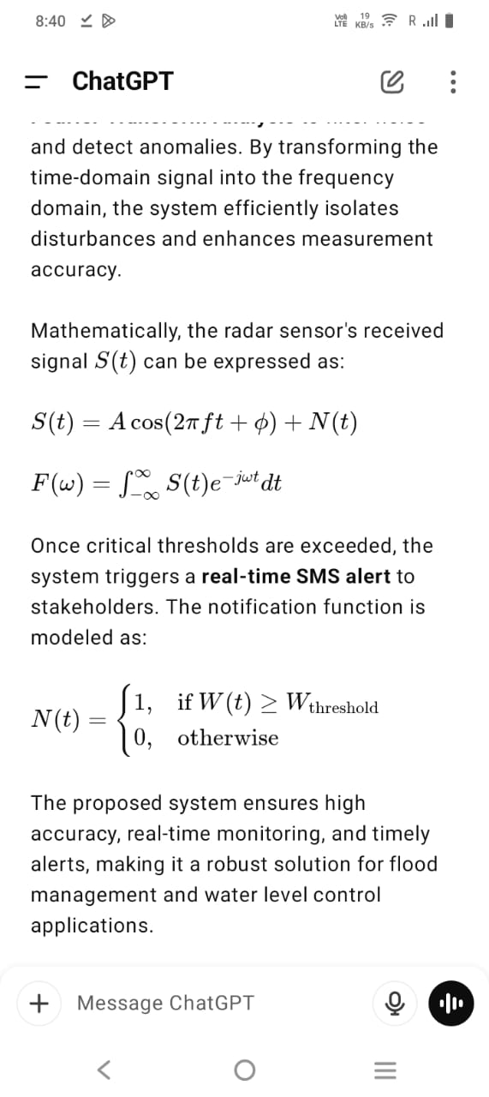

Once critical thresholds are exceeded, the system triggers a real-time SMS alert to stakeholders. The notification function is modeled as:



The proposed system ensures high accuracy, real-time monitoring, and timely alerts, making it a robust solution for flood management and water level control applications.

Summary:

Objective:

This project aims to develop a smart water level monitoring and alert system that utilizes radar sensors for accurate water level detection, Fourier Transform analysis for data processing, and real-time SMS notifications to alert users of critical water levels. The system is designed for applications such as flood monitoring, reservoir management, and smart irrigation systems.

System Components and Architecture

1. Hardware Components

Radar Sensor (FMCW/LIDAR-based, e.g., HB100, AWR1642, or Ultrasonic Radar) – Provides non-contact, high-precision water level measurement.

Microcontroller (ESP32, Arduino Mega, Raspberry Pi, or STM32) – Processes data from the sensor and controls system operations.

GSM Module (SIM800L/900A/4G LTE) – Sends real-time SMS alerts to users.

Power Supply (Rechargeable Battery/Solar Panel/Adapter 5V-12V) – Ensures autonomous operation.

LCD Display/LED Indicators (Optional) – Displays real-time water levels and status.

IoT Connectivity (Optional WiFi/Bluetooth/GPRS/LoRaWAN) – Sends data to cloud platforms for remote access.

2. Software Components

Embedded Programming (C, Python, or Micropython) – Controls the microcontroller and interfaces with the radar sensor and GSM module.

Fourier Transform Algorithm (FFT/DWT Filtering in Python/Matlab) – Used to filter sensor noise and detect abnormal water level trends.

Threshold-Based Alert System – Detects water level breaches and triggers SMS alerts.

Cloud Storage (Optional: Firebase, ThingsBoard, AWS IoT, or Blynk) – Stores real-time data for remote monitoring.

Mathematical Model and Analysis

1. Radar-Based Distance Measurement

Radar sensors calculate distance by measuring the time delay between the transmitted and received signals. The formula is:

d = \frac{c \cdot t}{2}

= Distance from the radar sensor to the water surface (m)

= Speed of electromagnetic waves (~ m/s)

= Round-trip time of the radar pulse (s)

The actual water level is obtained by subtracting this measured distance from the total height of the reservoir/tank:

L = H - d

= Water level

= Height of the tank/reservoir

2. Fourier Transform for Noise Filtering

Environmental factors such as wind, ripples, and sensor errors introduce fluctuations in the signal. To remove high-frequency noise, we apply Fourier Transform (FT):

F(\omega) = \int_{-\infty}^{\infty} f(t) e^{-j\omega t} dt

= Time-domain signal from the radar sensor

= Frequency component

= Frequency-domain representation of the signal

Filtering Process:

Convert the time-series data to the frequency domain using FFT (Fast Fourier Transform).

Remove high-frequency noise components by applying a low-pass filter.

Convert the cleaned data back to the time domain using the Inverse Fourier Transform (IFT).

Filtered water level readings allow more reliable decision-making.

3. Critical Water Level Alert System

To determine whether an alert should be triggered, a threshold-based system is implemented:

L \geq L_{critical} \Rightarrow \text{Send SMS Alert}

= Current water level

= Predefined critical water level

If exceeds , the GSM module sends an SMS alert to the designated phone numbers.

4. Real-Time SMS Notification Logic

The GSM module is programmed to send messages when the water level crosses set thresholds. Example code for Arduino (using SIM800L):

Reference Code:

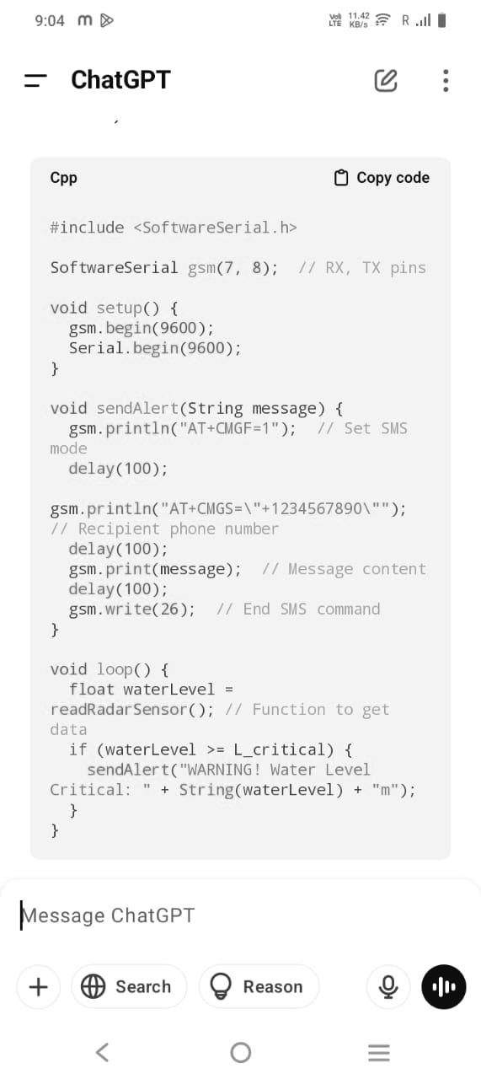

Advantages of the Proposed System

1. Non-Contact Measurement: Radar sensors provide reliable and maintenance-free operation.

2. Noise Filtering: Fourier Transform enhances accuracy by removing unwanted fluctuations.

3. Real-Time Alerts: Immediate SMS notifications help in disaster prevention.

4. Scalability: Can be integrated with IoT for cloud monitoring and remote access.

5. Autonomous Operation: Solar-powered options make it suitable for remote areas.

Applications

1. Flood Monitoring Systems: Early warnings for river overflows.
2. Reservoir/Tank Management: Preventing overflows and optimizing storage.
3. Industrial Liquid Monitoring: Ensuring safe levels in chemical tanks.
4. Agricultural Irrigation Control: Automating water supply management.

Conclusion

The proposed Smart Water Level Monitoring System integrates radar-based sensing, Fourier Transform noise filtering, and real-time GSM alerts to deliver highly accurate, reliable, and contactless monitoring. It is ideal for flood prevention, reservoir management, and industrial applications, ensuring early warnings and data-driven decision-making. The combination of non-contact sensors, real-time processing, and remote communication makes this system robust, cost-effective, and scalable for various environments.

References:

1. "The Least-Square Fourier-Series Model-Based Evaluation and Forecasting of Monthly Average Water-Levels"

Author: Zong-chang Yang

Publication: Environmental Earth Sciences, May 2018

2. "Predicting Groundwater Level Using Fourier Series Integrated with Least Square Estimation Method"

Author: Manoj K. Jha

Publication: American Journal of Engineering and Applied Sciences, March 2014

3. "Calibrating a Model of Depth to Water Table Using Fourier Series and Simpson Numerical Integration"

Authors: Kaiyan Wang, Jun Li, Wenke Wang, Zaiyong Zhang, Xusheng Wang, Qi Wang, Tian Chyi Jim Yeh, Yonghong Hao

Publication: Journal of Hydrology, May 2023

4. "Estimation of Groundwater Level and Parameters Using Fourier Series and Extended Kalman Filter"Authors: K. Fujino, K. Jinno

Publication: Journal of Groundwater Hydrology, June ,1994.

5. "Predictive Modeling of Hourly Water-Level Fluctuations Based on the DCT Least-Squares Extended Model"

Author: Zong-chang Yang

Publication: Water Resources Management, February 2018

6. "Non-contact Water Level Measurement Using Millimeter-Wave Radar"

Authors: B. Choi, J. Kim, S. Park, Y. Lee

Publication: IEEE Sensors Journal, 2020

7. "Development of a Radar-Based Water Level Monitoring System for Smart Irrigation"

Authors: M. Ahmed, R. Kundu, S. Bhattacharya

Publication: Agricultural Water Management, 2021

8."A GSM-Based Smart Water Monitoring System for Real-Time Applications"

Authors: N. Kumar, P. Patel, A. Dutta

Publication: IEEE Transactions on Instrumentation and Measurement, 2019

9. "IoT-Based Water Level Monitoring System with Real-Time SMS Alerts"

Authors: A. Roy, P. Singh, K. Verma

Publication: International Journal of Smart Sensing and Intelligent Systems, 2022